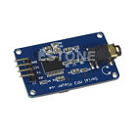

# **UART Control Serial MP3 Music Player Module For Arduino/AVR/ARM/PIC**

# 

|  |
| --- |

# 

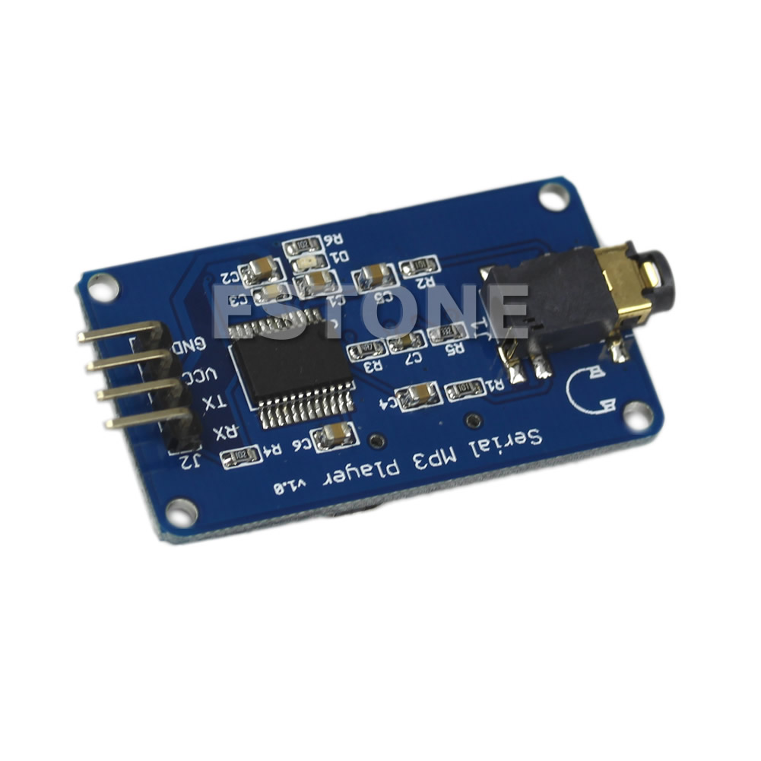

* **100% brand new and high quality**
* Features:
* Support sampling frequency (kHz):8 / 11.025 / 12 / 16 / 22.05 / 24 / 32 / 44.1 / 48
* Support file format:MP3/WAV
* Support Micro SD card, Micro SDHC Card
* 30 class adjustable volume
* UART TTL serial control playback mode, baud rate is 9600bps
* Power supply can be 3.2 ~ 5.2VDC
* Size:43mm x 25mm
* Quantity:1PC

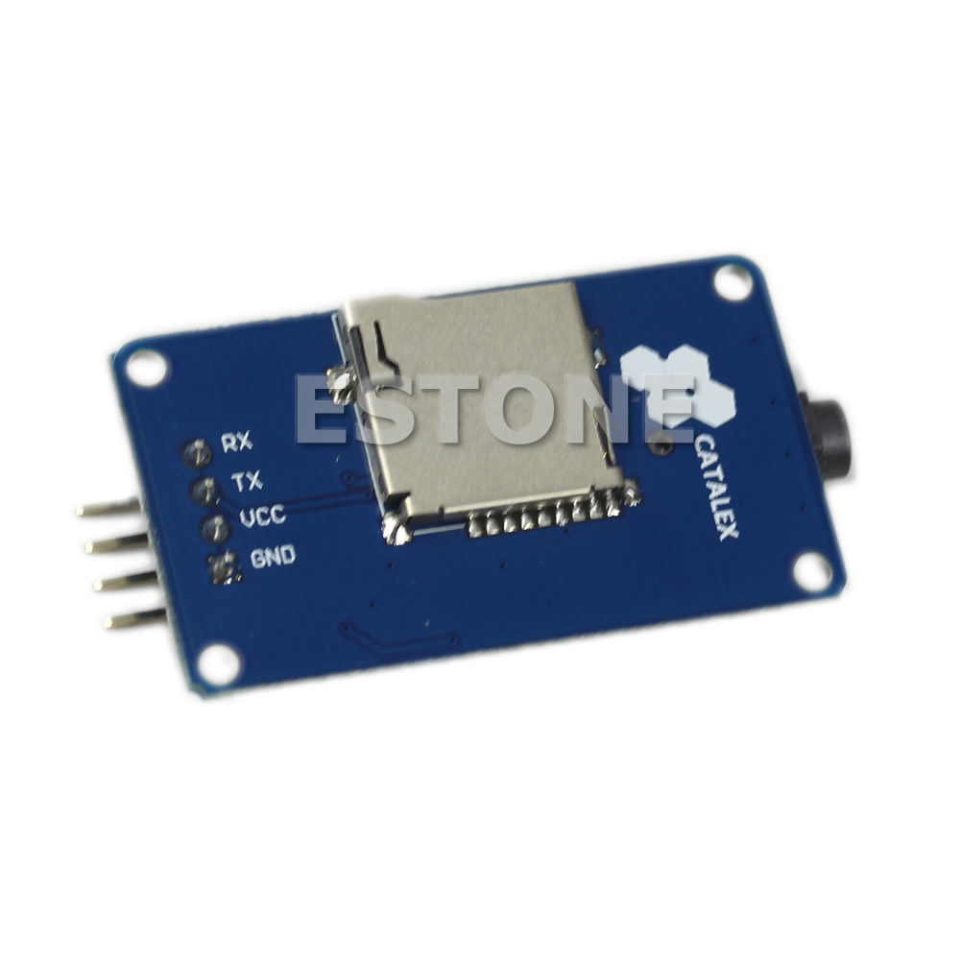

More Information:

Catalex Serial MP3 player

<http://www.amazingtips247.co.uk/2016/11/how-to-play-sound-tracks-from-different.html>

<http://www.amazingtips247.co.uk/2015/11/how-to-play-sound-tracks-with-catalex.html>

PDF manual

<http://geekmatic.in.ua/pdf/Catalex_MP3_board.pdf>